How to pray the Living Rosary

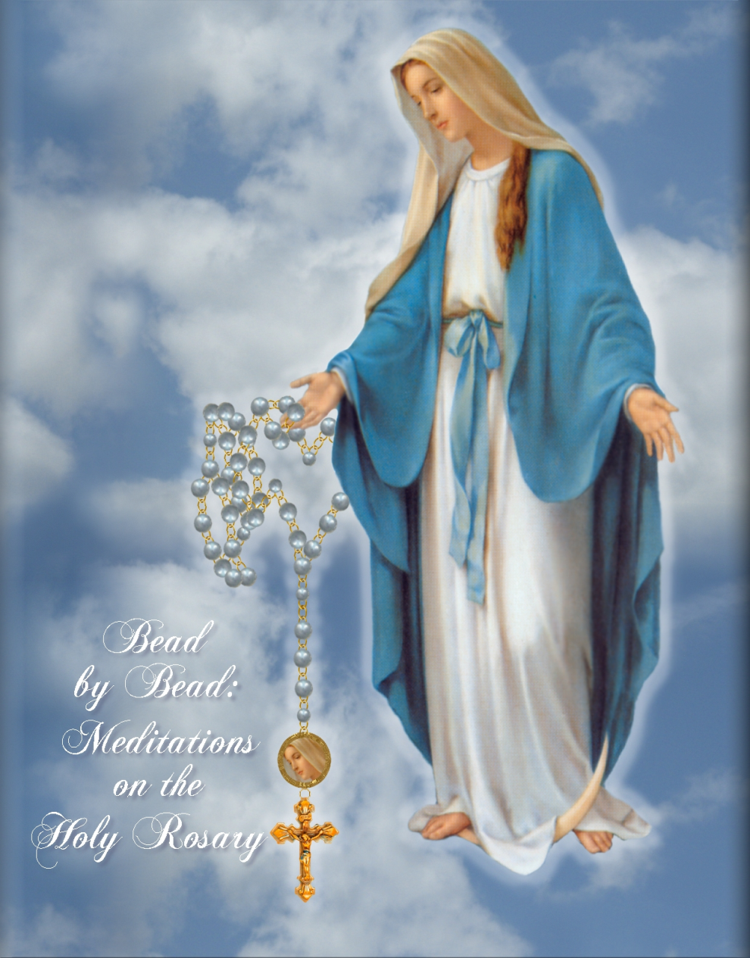

The Rosary will begin the 1st of each month. Each person who joins will be assigned to specific decades and mysteries which will be for 20 months, and with completion of the 20 months you will start over from the beginning, that’s why it’s called This Living Rosary it lives on. You will pray one (1) decade of the Rosary for the period of one (1) Month and on the first of the following month, you will go on to the following decade. You do not have to meet anyone, you pray individually anytime of the day at your own convenience.

While praying and meditating your assigned decade each day of every month Our Blessed Mother Mary is leading you slowly to Her Son Jesus.

Remember: When it is your turn to pray the First Decade of each Mystery of the Rosary, you will also have to say the prayers that begin the Rosary: The Apostles Creed, The Our Father, The three (3) Hail Marys’ The Glory Be to the Father, and The O, my Jesus, forgive us our sins. Likewise when it is your turn to pray the Fifth Decade of each Mystery of the Rosary, you will have to say the ending prayer: Hail, Holy Queen.

If, however, you forget to pray your decade of the Rosary on a day, please pray it twice the following day. This way you will have completed the Rosary which was not completed the day before.

Please include with your intentions, prayers for the spiritual and temporal needs of your parish, prayers for Pro-Life Intentions, prayers for Our Holy Father, all Bishops, Priests, Religious, and for the petitions of those who have joined the living Rosary Family. Join us in Praying the Gospel and Changing the World!

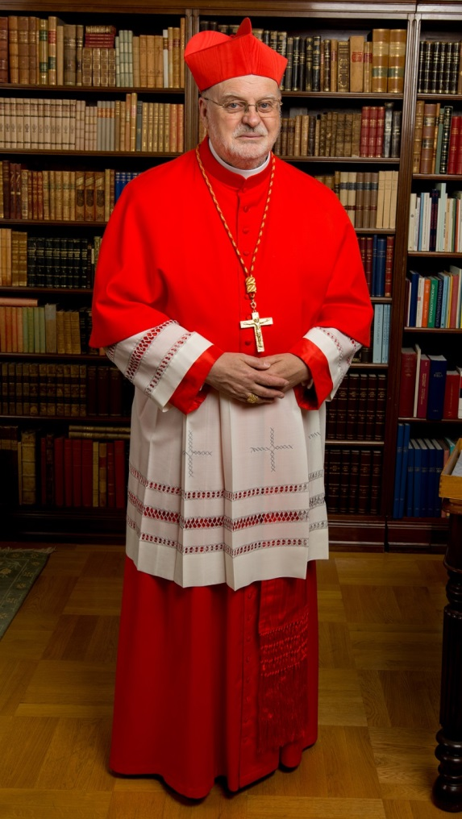

Eminence Cardinal Anders Arborelius OCD, is the protector of the Living Rosary Apostolate.

**JOYFUL MYSTERY MEDITATIONS**

**Annunciation** - ***Humility***  
"Mary received with deep humility the news of the Angel Gabriel that she was to be the Mother of the Son of God. Grant that I may always accept the will of God with humility like Mary

**Visitation** - ***Love of Neighbor***  
"Mary showed true charity in visiting Elizabeth and remaining with her for three months before the birth of John the Baptist. Grant me the grace to support and love my neighbor like Mary."

* **Nativity** - ***Poverty***  
  "Mary lovingly accepted the poverty of the stable, although she was to give birth to our God and Redeemer. Grant me the grace to endure poverty like the Holy Family when I long for richer things."
* **Presentation** - ***Obedience***  
  "Mary and Joseph observed the law of God in presenting the Child Jesus in the temple. Help me to grow in the virtue of obedience."
* **Finding in the Temple** - ***Joy in Finding Jesus***  
  "Mary was filled with sorrow at the loss of Jesus, her Son, and overwhelmed with joy in finding Him in the temple surrounded by the teachers. Obtain for me the joy of staying close to Jesus."

**LUMINOUS MYSTERY MEDITATIONS**

* **Baptism of Jesus in the Jordan** - ***Openness to the Holy Spirit***"Jesus, at Your Baptism, You remained open to the Holy Spirit and were filled with the power of God to begin Your public ministry. Through my Baptism and Confirmation, may I remain ever open to the Spirit of God in my life."
* **Manifestation of Jesus at the Wedding at Cana** - ***To Jesus through Mary***"Mary, you know my needs and the needs of all your spiritual children so well. When life is hard and I face a difficult situation, please pray to Jesus on my behalf. Help me to follow your counsel by doing whatever He tells me."
* **Proclamation of the Kingdom of God** - ***Repentance and Trust in God***"Lord Jesus, You came as the Light into the world, proclaiming the Good News. With great boldness and power, You dispelled the darkness of sin, death, and the Evil One in the world. Help me to repent of my own sin and to trust more in You."
* **Transfiguration of Jesus** - ***Desire for Holiness***  
  "Lord Jesus, You revealed Your glory to encourage the disciples to fix their eyes upon thehope of glory when faced with trials. Help me, Lord, to fix my eyes upon You in the glory of Heaven. Fill me with the desire to become a saint."
* **Institution of the Eucharist** - ***Adoration***  
  "Lord Jesus, as I am nourished by your Body and Blood in Holy Communion, help me to be transformed more and more into Your image. And may I spend time adoring Your Body and Blood, Soul and Divinity in the Most Blessed Sacrament
* **SORROWFUL MYSTERY MEDITATIONS**

**Agony in the Garden** - ***Sorrow for Sin***

"Jesus, You suffered a bitter agony in the Garden of Gethsemane because of our sins. Lead me to prayer in my time of need and grant me true contrition for my sins."

**Scourging at the Pillar** – ***Purity***

"Jesus, You remained pure of heart even when Your flesh was torn and scourged by those who hated You. Help me to grow in the virtue of purity even when I suffer."

**Crowning with Thorns** - ***Courage***

"Jesus, You patiently endured the pain from the crown of sharp thorns that was forced upon Your head. Grant me the strength to have moral courage to follow You."

**Carrying of the Cross** - ***Patience***

"Jesus, You willingly carried Your Cross for love of Your Father and all people. Grant me the forbearance and patience to carry my cross in difficult moments."

**Crucifixion** - ***Perseverance***

"Jesus, You bravely endured torture on the Cross and gave up Your life for the salvation of all humankind. Grant me peace of mind, body, and spirit, and the grace of perseverance in adversity."

**GLORIOUS MYSTERY MEDITATIONS**

**Resurrection** – ***Faith***

"Jesus, You rose from the dead in triumph and remained for forty days with Your disciples, instructing them and encouraging them. Grant me the desire to always have faith in You, my Risen Lord."

**Ascension**-***Hope***

"Jesus, You instilled in the disciples the virtue of hope in life everlasting and commanded them to carry Your Gospel throughout the world. As You sit at the Fathers right hand in heaven, grant me the grace to grow in the virtue of hope and inspire me to lead others to You."

**Descent of Holy Spirit *- Love for God***

"Jesus, Your disciples received the Holy Spirit to foster their love for You. Grant that I may show my love for You by proclaiming the Good News of salvation."

**Assumption** - ***Grace of a Happy Death***

"Mary, you were assumed body and soul into heaven by the power of God, and united with your Divine Son, Jesus. Obtain eternal happiness with Him for me."

**Coronation of the Blessed Virgin Mary** - ***Trust in Mary’s Intercession***

"Mary, you humbled yourself before God and you were crowned Queen of Heaven. Bless me with the love of the Holy Trinity and intercede for me in Heaven.

**The Historical Presentation of this Living Rosary**

During World War II at a Lenten retreat in Poland, servant of God Jan Tyranowski a Catholic layman, was asked by Salesian Priests to organize Living Rosary groups since all priests were targeted by the Nazi regime. Groups were composed of fifteen devotees each meditating upon one of the fifteen mysteries daily. This ministry became a cornerstone for the Catholic underground in 1940. From these original devotions came ten men into the priesthood. At St. Stanislaus University in Krakow, Jan was the youth leader and central figure in the spiritual formation of the young Karol Wojtyla. Karol attended these meetings entitled the Living Rosary which fostered many vocations including Fr. Karol Wojtyla who in turn became Pope John Paul II.

In Mitchell South Dakota, US, in 2003, the two priests from neighboring parishes asked their parishioners to start the Living Rosary for Lent. One of these priests Fr. Andrew being from Poland, was friends with Fr. Wojtyla. Father Andrew prayed the Living Rosary from his youth and instructed parishioners on how to pray the Living Rosary. In turn these parishioners’ numbers grew totaling five hundred devotees, thus began this Living Rosary in the US. The group asked others to help spread this beautiful devotion and rediscover the power of the Rosary. As of June 2019, this Living Rosary has spread to several states and countries in the world.

This Living Rosary embraces the hearts of thousands of families and individuals through the meditation on one decade daily, unifying their intentions with the Roman Catholic hierarchy, religious, parishes and pro-life endeavors. The devotion shows how the mysteries of Christ's life can be transformed into our daily lives, allowing the experience to live and love as Christ asks of us. Meditating with Jesus and Mary through these mysteries help us to discover the messages her son intends for our daily growth.

Join us in Praying the Gospel and Changing the World!

Do you want to join or want to know more, please contact;

The Living Rosary Apostolate, info@livingrosaryapostolate.com